TRAINING AND PLACEMENT CELL
ACADEMIC YEAR 2024-2025
One-Day Faculty Development Programme (FDP) titled ICONquer 16.11.2024
The Training and Placement Cell of Achariya Arts and Science College conducted a One-Day Faculty Development Programme (FDP) titled ICONquer.
The session started with the Welcome address by Ms. F. Josephine dayana, Assistant professor and Special address was given by Dr. T. Janarthanan, Vice Principal and followed by the honouring of the resource person by our respected Principal Dr.S.Vimalanand.
The Resource person Ms.G.Nithyapriya,SME in association with SYASANS Career Analytics, Chennai presided over the session in an enthusiastic way.
The first session of the FDP provided a detailed overview of the POSH (Prevention of Sexual Harassment) Act, along with insights into addressing gender bias and the importance of self-analysis.
The second session was entirely activity-based, focusing on group tasks that highlighted the significance of team building and collaboration among faculty members.
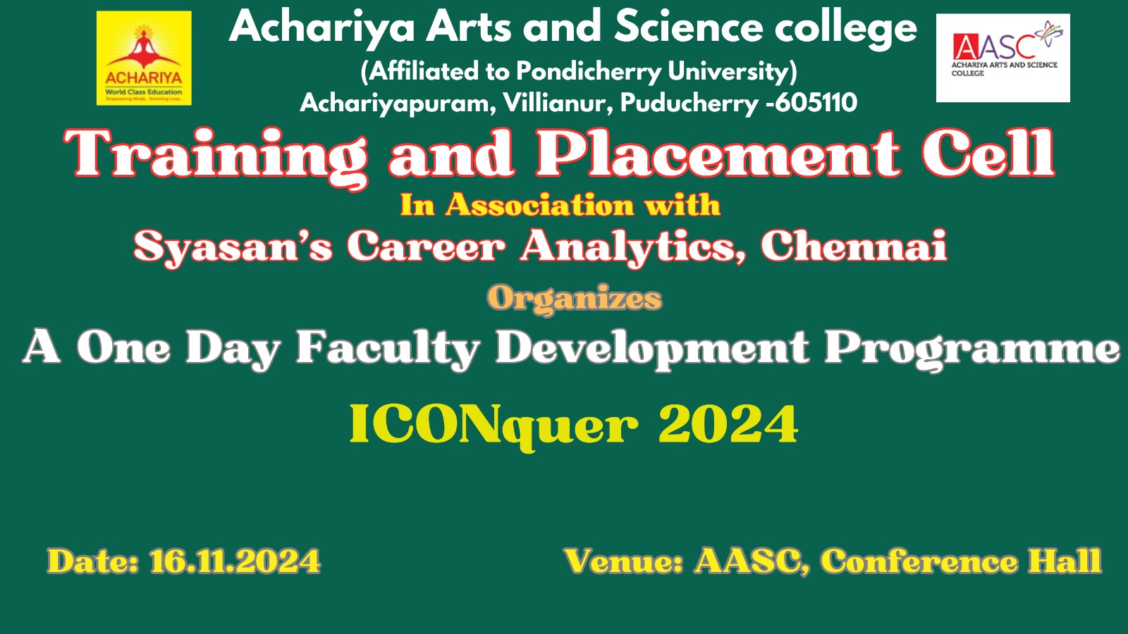
The day ended with the feedback session and the vote of thanks by Mr. Nethraprakash HOD, BBA.

